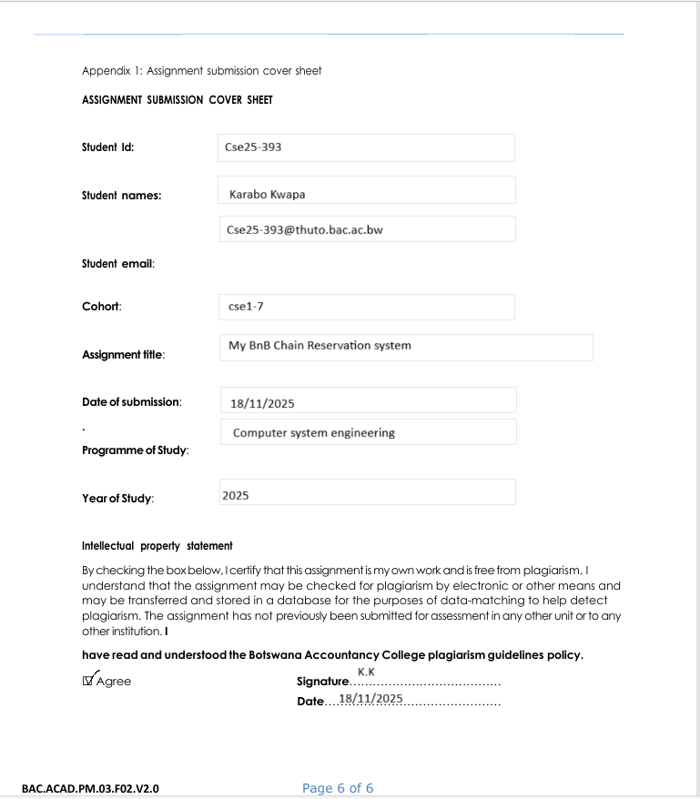
21/05/2026
23/05/2026
2026
WMD
Olympus
Garments
GitHub link; https://timothykwapa3-design.github.io/cse25-393/

1.Website Specifications:
a) Website objective
Introduction
The goal of the Olympus website is to help diversify and provide a selection of different garments to enhance street culture aspect of fashion to issue scalability aiming for ecological and a circular economy on a global scale.
Goals of company
-The company will be able to promote Sustainable Ecommerce through use of website by targeting a global market.
-Engaging Community by involving the target audience in collection drops, voting on next designs and promoting collabs.
-Engaging brands to collaborate with Website to help promote local brands to create international exposure.
-Promoting local craftmanship through global trade.
-Increasing eco-friendly resource to appeal to eco-conscious youth (product care, recycle fabrics and eco-friendly packaging).
-Bridging digital and physical spaces by creating a seamless style expression across real and online space for easier access by the Youth.
b) Target audience
Engaging individuals, fashion enthusiast youth, models and eager creatives and artists diversifying their fashion lifestyle with agile and distinct apparel to equip them with garments that showcase individuality .
Demographic
Age
16-45
Gender
male/ female(Unisex)/other
Location
global scale(rural and urban areas with access to shopping warehouses and post offices , customs)
Technical Aptitude
-Individuals with aptitude in online transactions and online business competency
-Can be able to navigate the website and give detailed research about product preference.
-Basic skills in navigating the web and using a computer (Customers will be provided with links ,a about page to assist with information and teach users about website brand mission).
2. Information Design & Taxonomy
Page 1
Home Page
Displays Brand title design and reveal the brand slogan to help customers get an aesthetic appeal and interest in the website.
Adds features to display limited drops
Product categories
highlights new arrivals and collab drops
It presents different navigation bars to guide the customer into other pages linked to the website e.g. links to Product page, Intro page, Contact page
Page 2
Intro page
-Illustrates the different Collection options (T-shirts, pants, shirts, hoodies and sweaters)
-Brand design and slogan
-Brand collabs
-Adding Navigation paths to; Body (Features Displayed)
-Displaying products
Page 3
Product Page
This page holds different garments and collections
linked with the cart page
allows uses to add products to cart
Page 4
Contact Page
This page gives client to have access to contacting the company through different links and leaving reviews about product to give company feedback on products.
(Emails, survey, contact information and warehouse address)
Page 5
About Page
Customers get a sense of that the brand is about to help get a better feel of the product and the company vision. (product information, FAQ, Brand mission, brand identity)
Page 6
Cart Page
Linked with the product page, Is the page the allows check outs and shipping infomation
Low level fidelity
This illustrates the design structure and how the navigation of the different navigation paths direct the user to have access to different options accessible through the website.
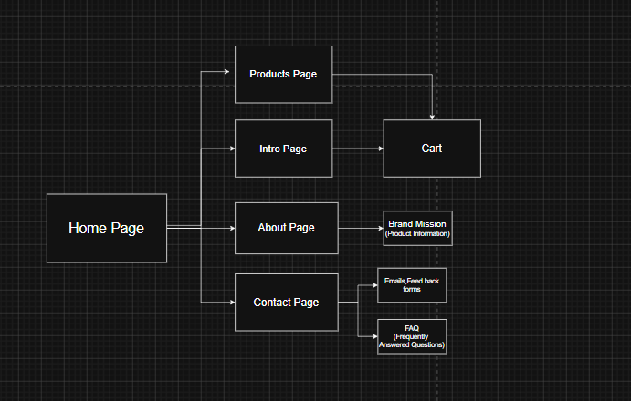

High level fidelity
This layout displays a demo webpage to aid in showcasing content and how the webpage will look like overall will look like.
Home page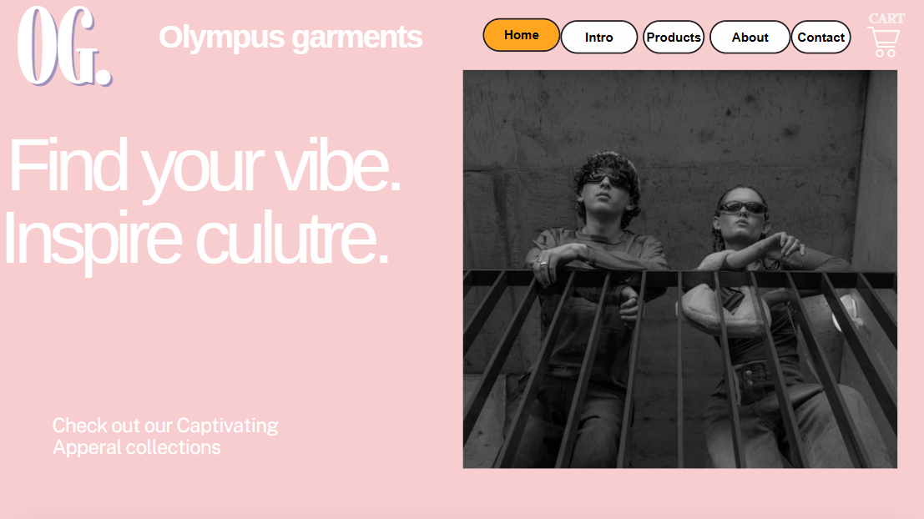
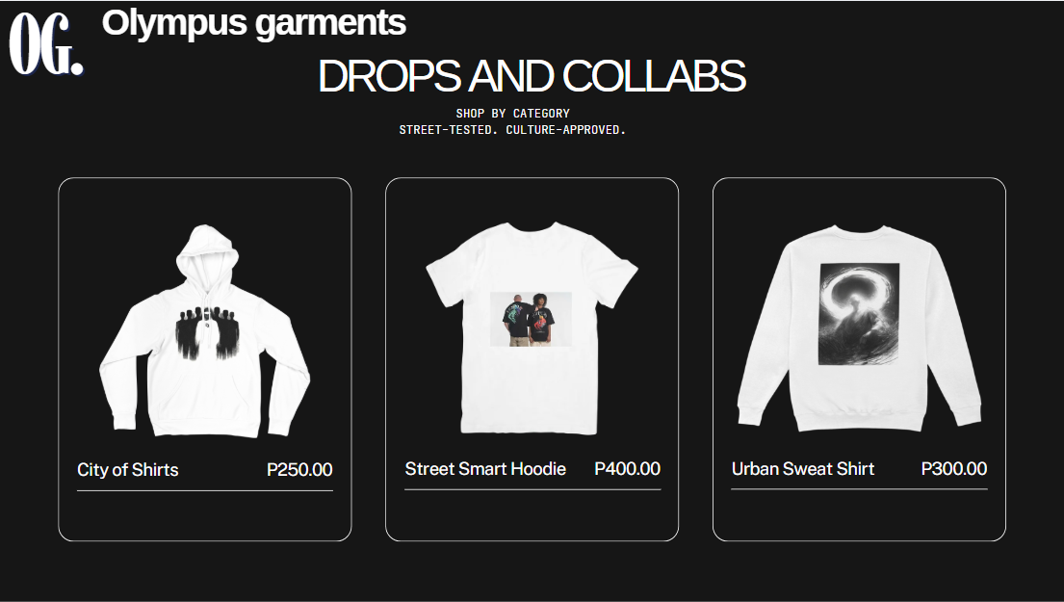
About page
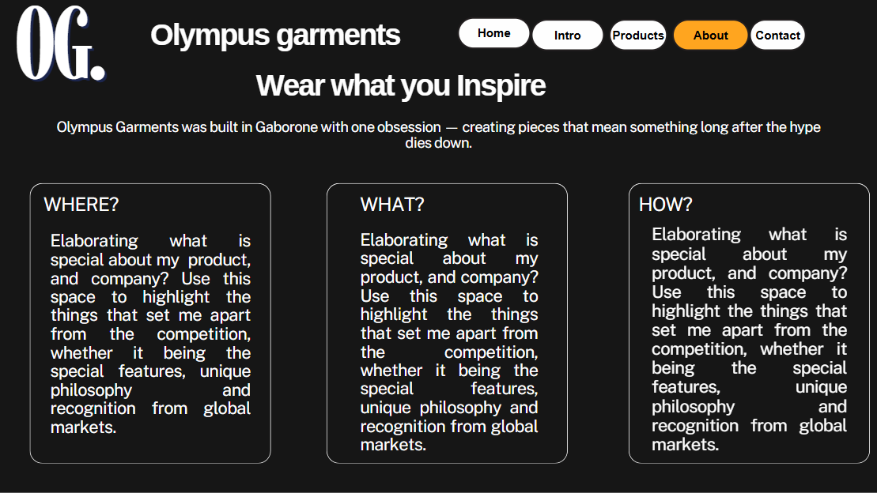
Intro Page
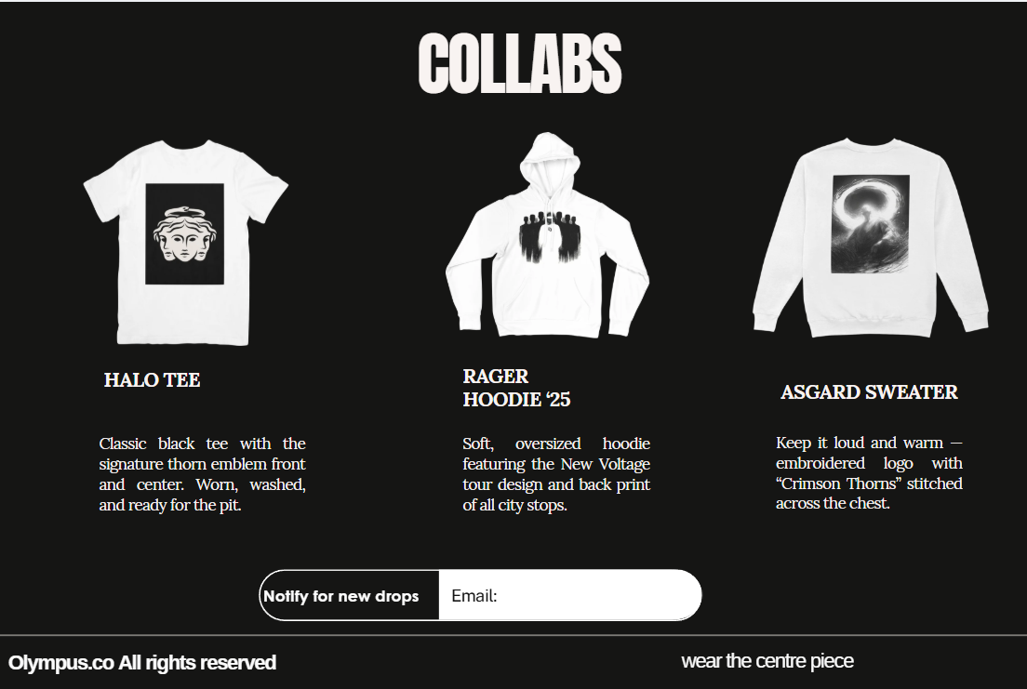
Contact Page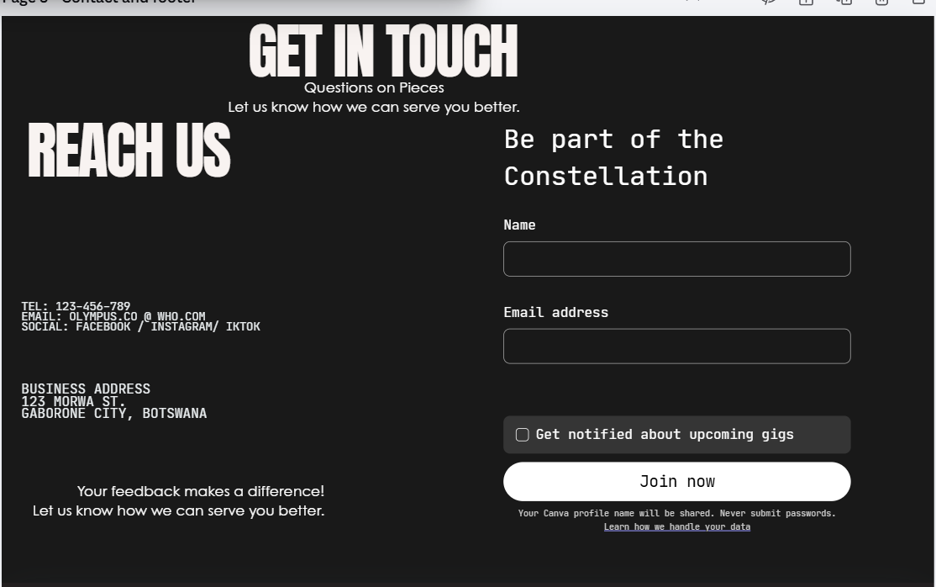

Cart Page
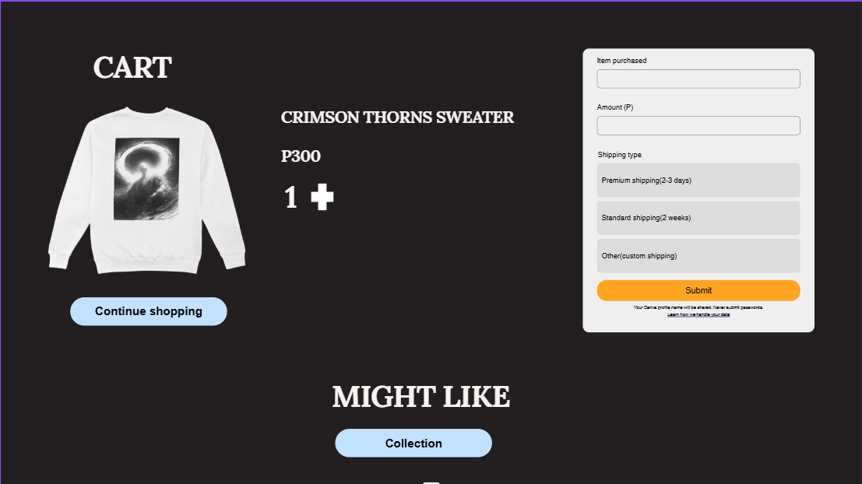

Footer section
Holds some navigation links and Brand name (most pages have this)
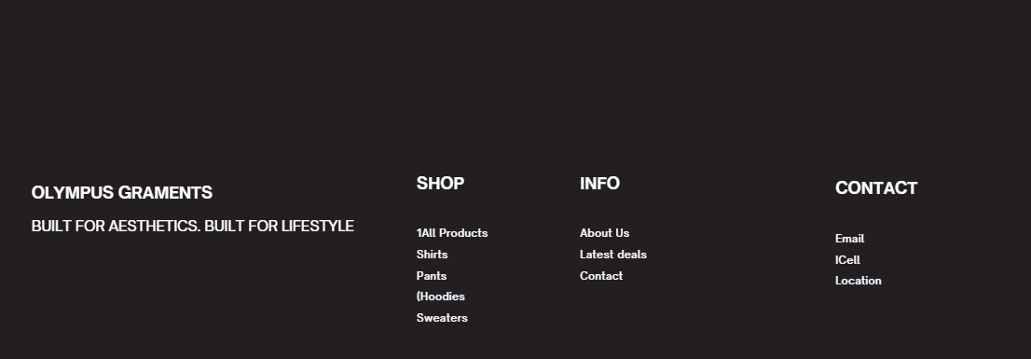

Technical Brief
GitHub
it is a cloud-based platform that aids in housing, maintaining and editing back-end code
Visual Studio
It is a programming software that allows code execution
Html (Using a fifth edition of the hypertext markup language that is used for back end code for the website design, it also aids to edit and publish the website platform
Canva/ Affinity
These are editing software that help designers create and illustrate projects
this will help me use it to create the high and low fidelity wire frames to help guide the project through the simple layout and display the final project
Pinterest
Platform that used to illustrate and share pictures
used this platform to collect images for products and collabs
W3schools
platform assisting in web development
used this to learn and apply java script within code and additional tools to create a seamless website.

